**BOOTSTRAP ASSIGNMENT**

**1. What are the advantages of Bootstrap ?**

**🡪** The advantages of Bootstrap are:

*1. Responsive Design:* Easily create mobile-friendly websites.

*2. Consistency:* Maintain a uniform design across your site.

*3. Time-Saving:* Use pre-designed components and templates.

*4. Customization:* Adapt Bootstrap to match your project's style.

*5. Cross-Browser Compatibility:* Ensures consistent performance.

*6. Community Support:* Access resources and help from a large community.

*7. Mobile-First:* Prioritizes mobile device compatibility.

*8. Accessibility:* Built-in features for web accessibility.

**2. What is a Bootstrap Container, and how does it work?**

**🡪** A Bootstrap container is a key building block in the Bootstrap framework for web development. It serves as a responsive container that centers and organizes webpage content. It works by defining a fixed-width space with automatic margins, ensuring that content looks consistent and visually appealing across various screen sizes and devices. This makes it easier for developers to create responsive and well-structured layouts for their websites.

**3. What are the default Bootstrap text settings in short?**

**🡪** Bootstrap provides default text settings, including alignment classes like `.text-left`, `.text-center`, `.text-right`, and formatting classes like `.font-weight-bold`, `.font-weight-normal`, and more. These classes help control text alignment, style, and appearance in a Bootstrap-powered web application.

**4. What do you know about the Bootstrap Grid System?**

**🡪** The Bootstrap Grid System is a responsive layout framework with a 12-column grid. It helps organize content on webpages into rows and columns, ensuring that designs adapt well to various screen sizes and devices. It's an essential part of Bootstrap, simplifying the creation of responsive and structured web layouts.

**5. What is the difference between Bootstrap 4 and Bootstrap 5.**

**🡪 <>**Bootstrap 4 and Bootstrap 5 are both popular front-end frameworks, but Bootstrap 5 is a more modern and streamlined version.

<>Bootstrap 5 no longer relies on jQuery, making it lighter and faster.

<> It offers improved customization options, introduces new components, and emphasizes accessibility.

<> While Bootstrap 4 is stable and widely used, Bootstrap 5 is the forward-looking choice for web development, offering enhanced performance and flexibility.

<> However, transitioning from Bootstrap 4 to Bootstrap 5 may require code adjustments due to changes in classes and components.

**6. What is a Button Group, and what is the class for a basic Button Group?**

**🡪**A Button Group in Bootstrap is a group of buttons that are visually grouped together, often used for related actions or options. Button Groups are used to create a cohesive UI element where multiple buttons appear as a single unit. They can be styled and configured in various ways.

<>The class for a basic Button Group in Bootstrap is `.btn-group`. You can use this class to wrap a set of buttons that you want to group together.

**7. How can you use Bootstrap to make thumbnails?**

**🡪** To create Bootstrap thumbnails:

1. Include Bootstrap CSS and JavaScript in your HTML document.

2. Use the `.card` class to create a thumbnail container.

3. Add content (image, title, description) within the `.card`.

4. Customize styles with Bootstrap classes or custom CSS.

5. Repeat the process for multiple thumbnails as needed.

**8. In Bootstrap 4, what is flexbox?**

**🡪** In Bootstrap 4, flexbox refers to the use of the CSS Flexible Box Layout model to create responsive and flexible page layouts.

🡪 Flexbox is a powerful tool for designing complex and adaptive layouts by distributing space and aligning content within containers.

🡪Bootstrap 4 leverages flexbox extensively, especially in its grid system, allowing developers to easily create responsive grids and align content vertically and horizontally.

🡪Flexbox simplifies layout tasks, making it a key feature for creating modern, responsive, and visually appealing web designs in Bootstrap 4.

🡪It offers greater control and precision in positioning elements within the layout, leading to more efficient and versatile web development.

**9. How can one create an alert in Bootstrap?**

**🡪** To create a Bootstrap alert:

1. Use the `.alert` class in a `<div>`.

2. Add a specific alert class like `.alert-success`, `.alert-warning`, etc., for the desired style.

3. Place your alert message or content within the `<div>`.

4. Optionally, include a close button for dismissal using the provided code structure.

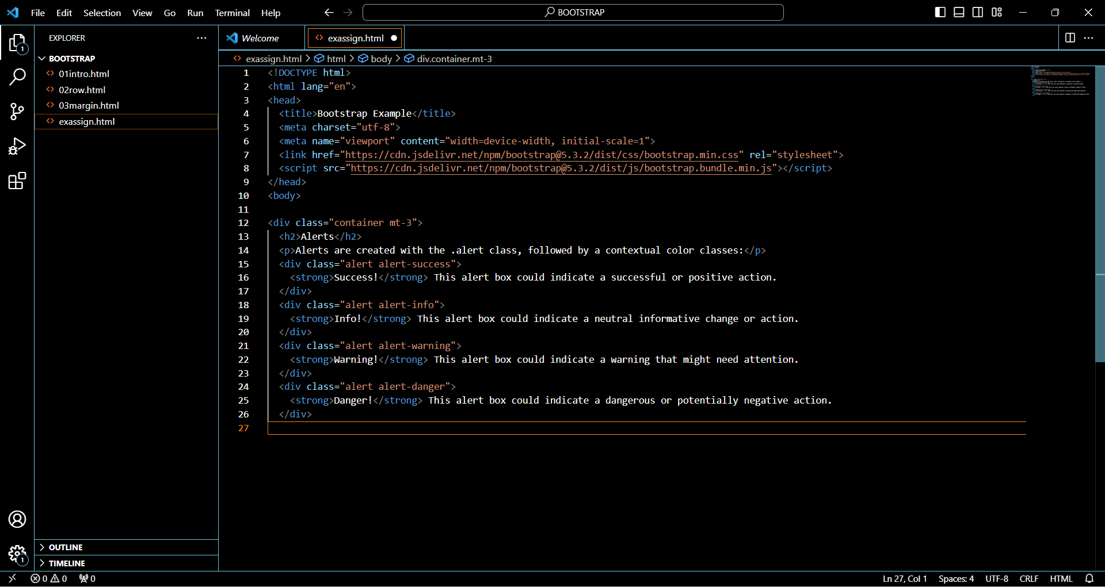

**10. What is a bootstrap card and how would you create one?**

**🡪** A Bootstrap card is a content container used for organized and visually appealing display of information. To create one, use the `.card` class for the container, add content inside (text, images, buttons), and customize styles as needed using Bootstrap classes or your own CSS. Repeat the process to create multiple cards.

**EXAMPLE:**

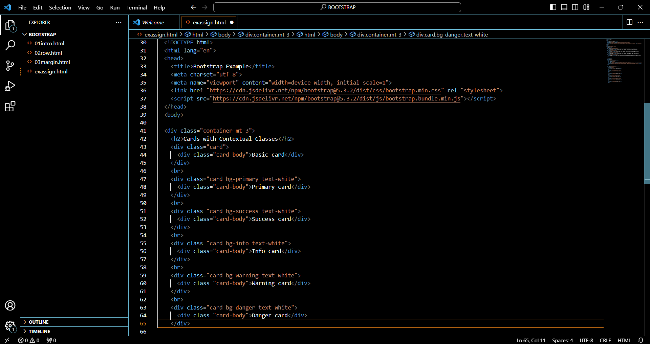

**PRACTICAL 1:**

**Q.**

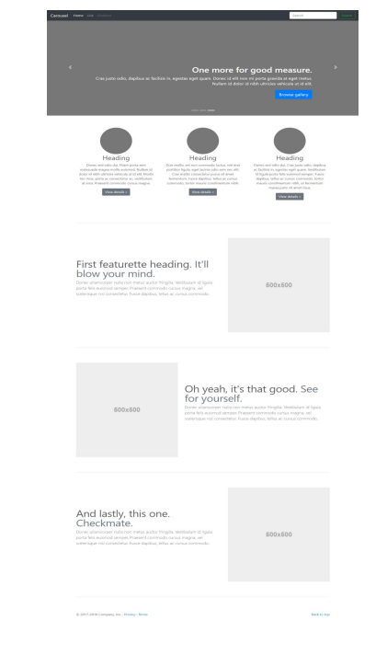

**🡪** 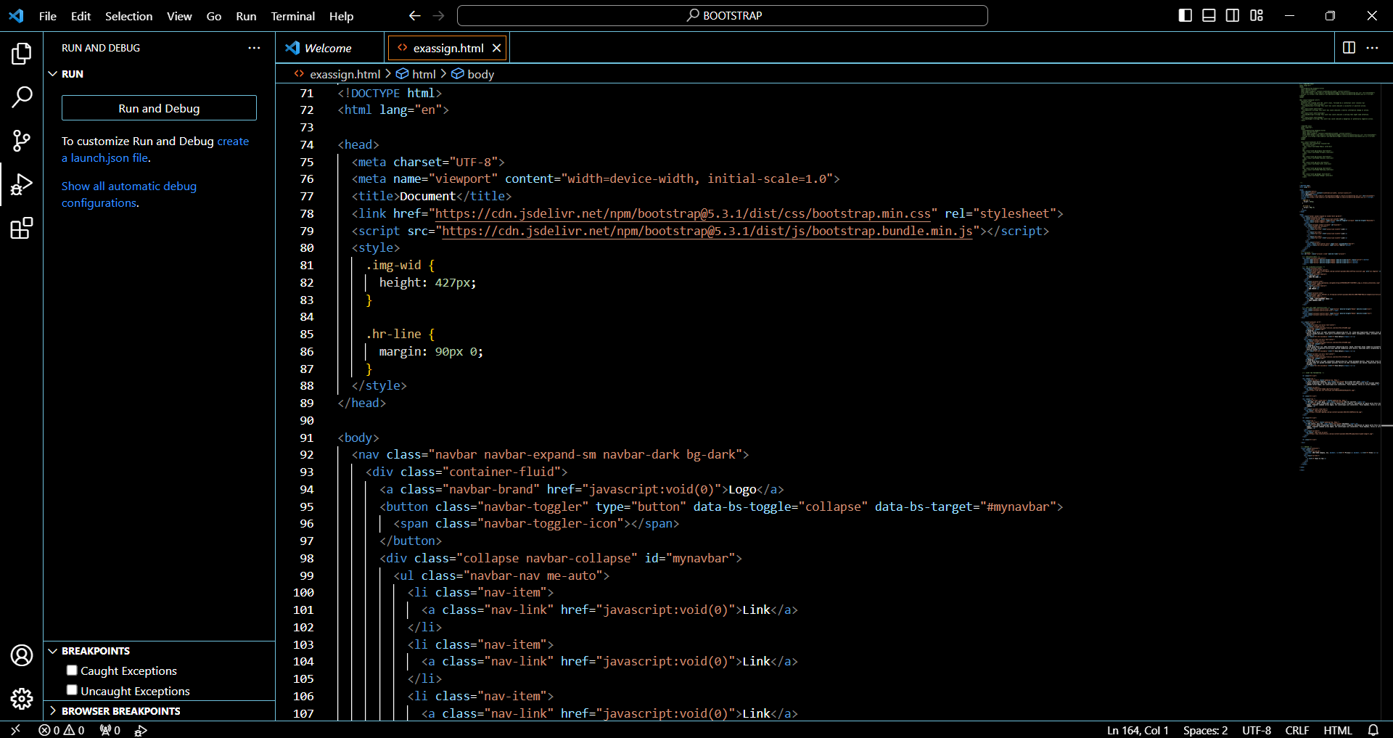

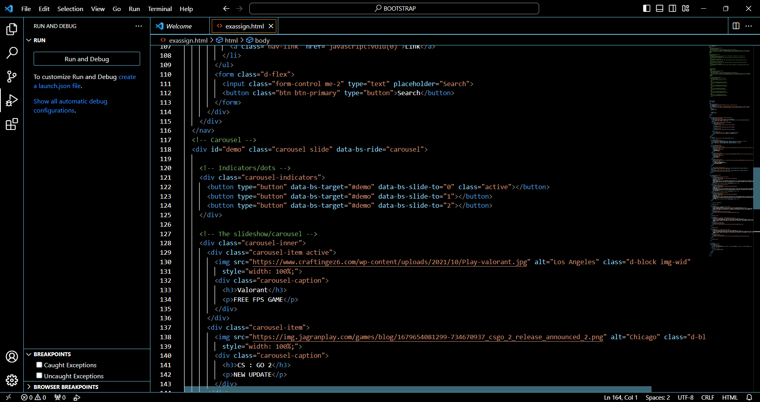

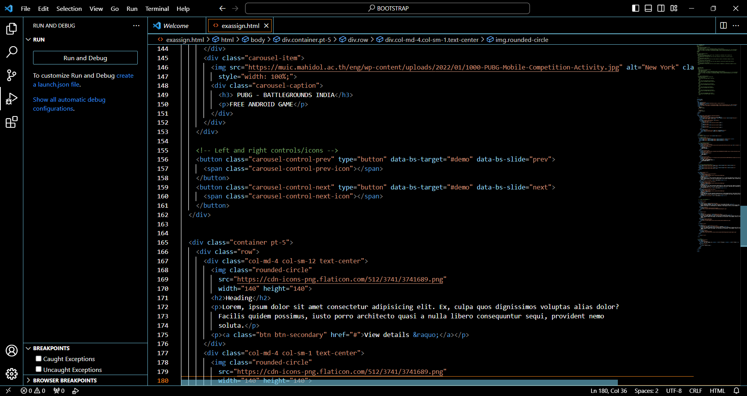

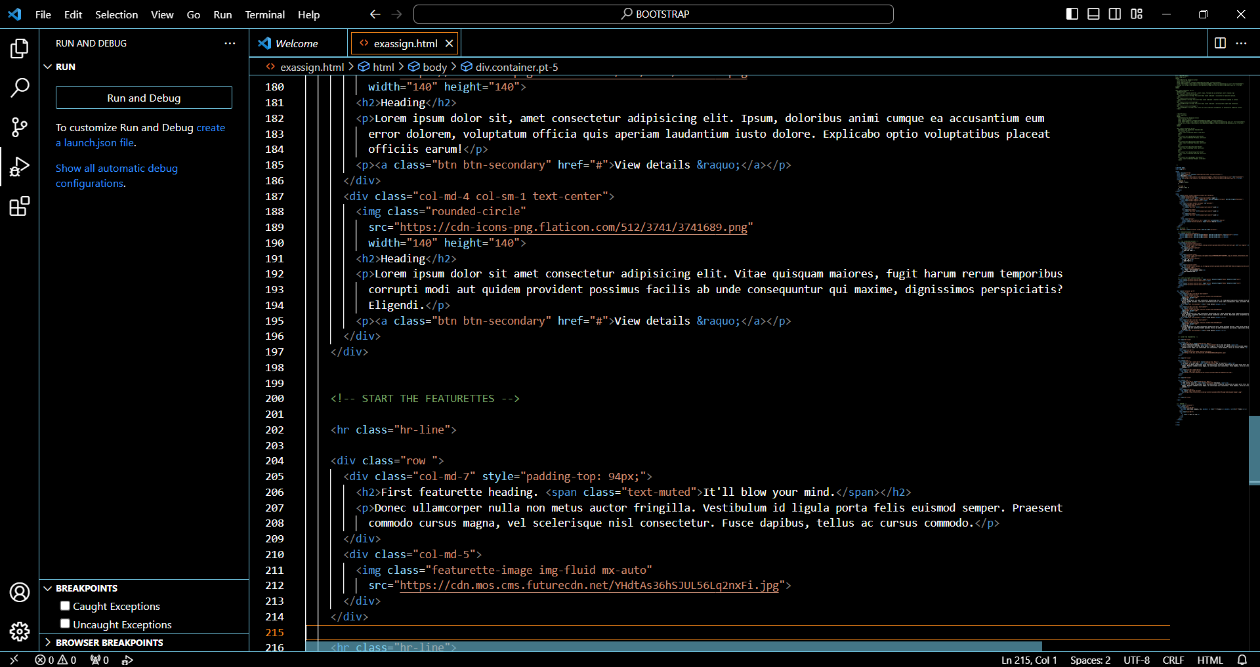

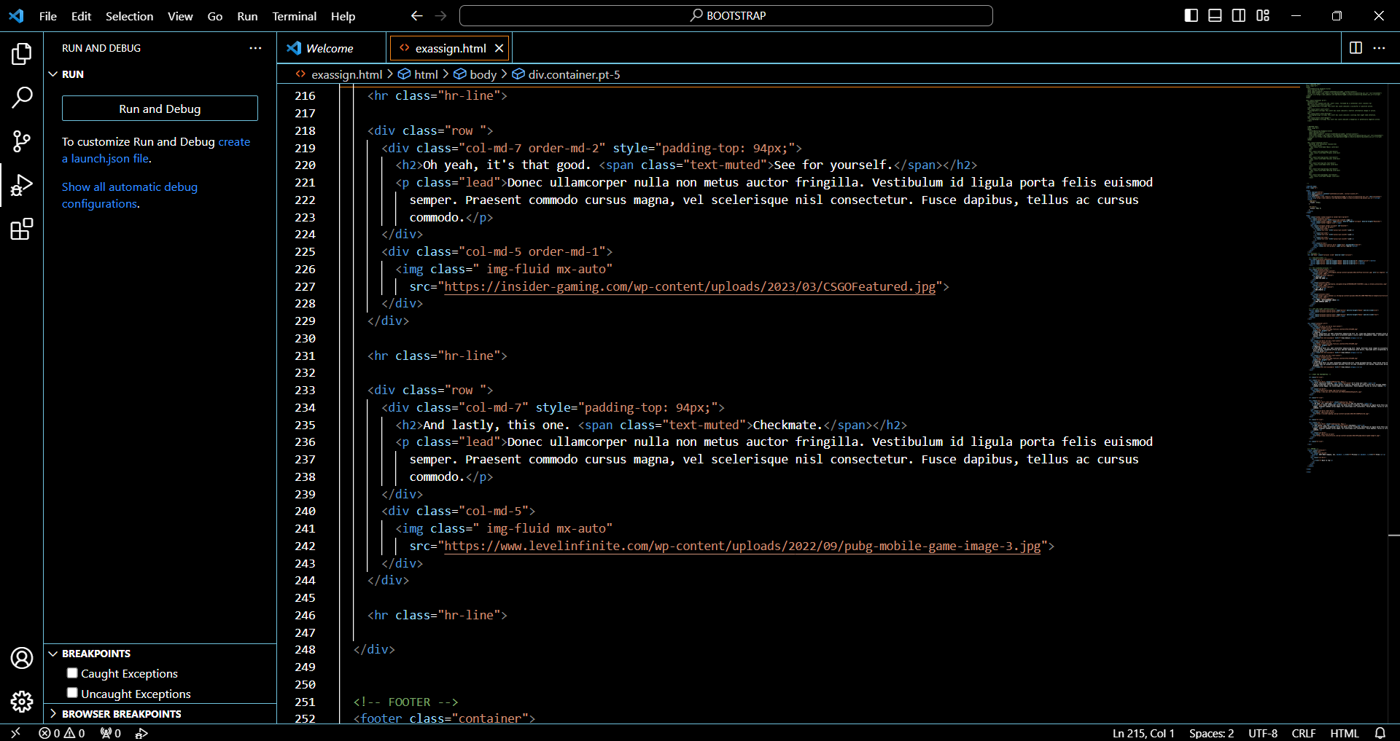

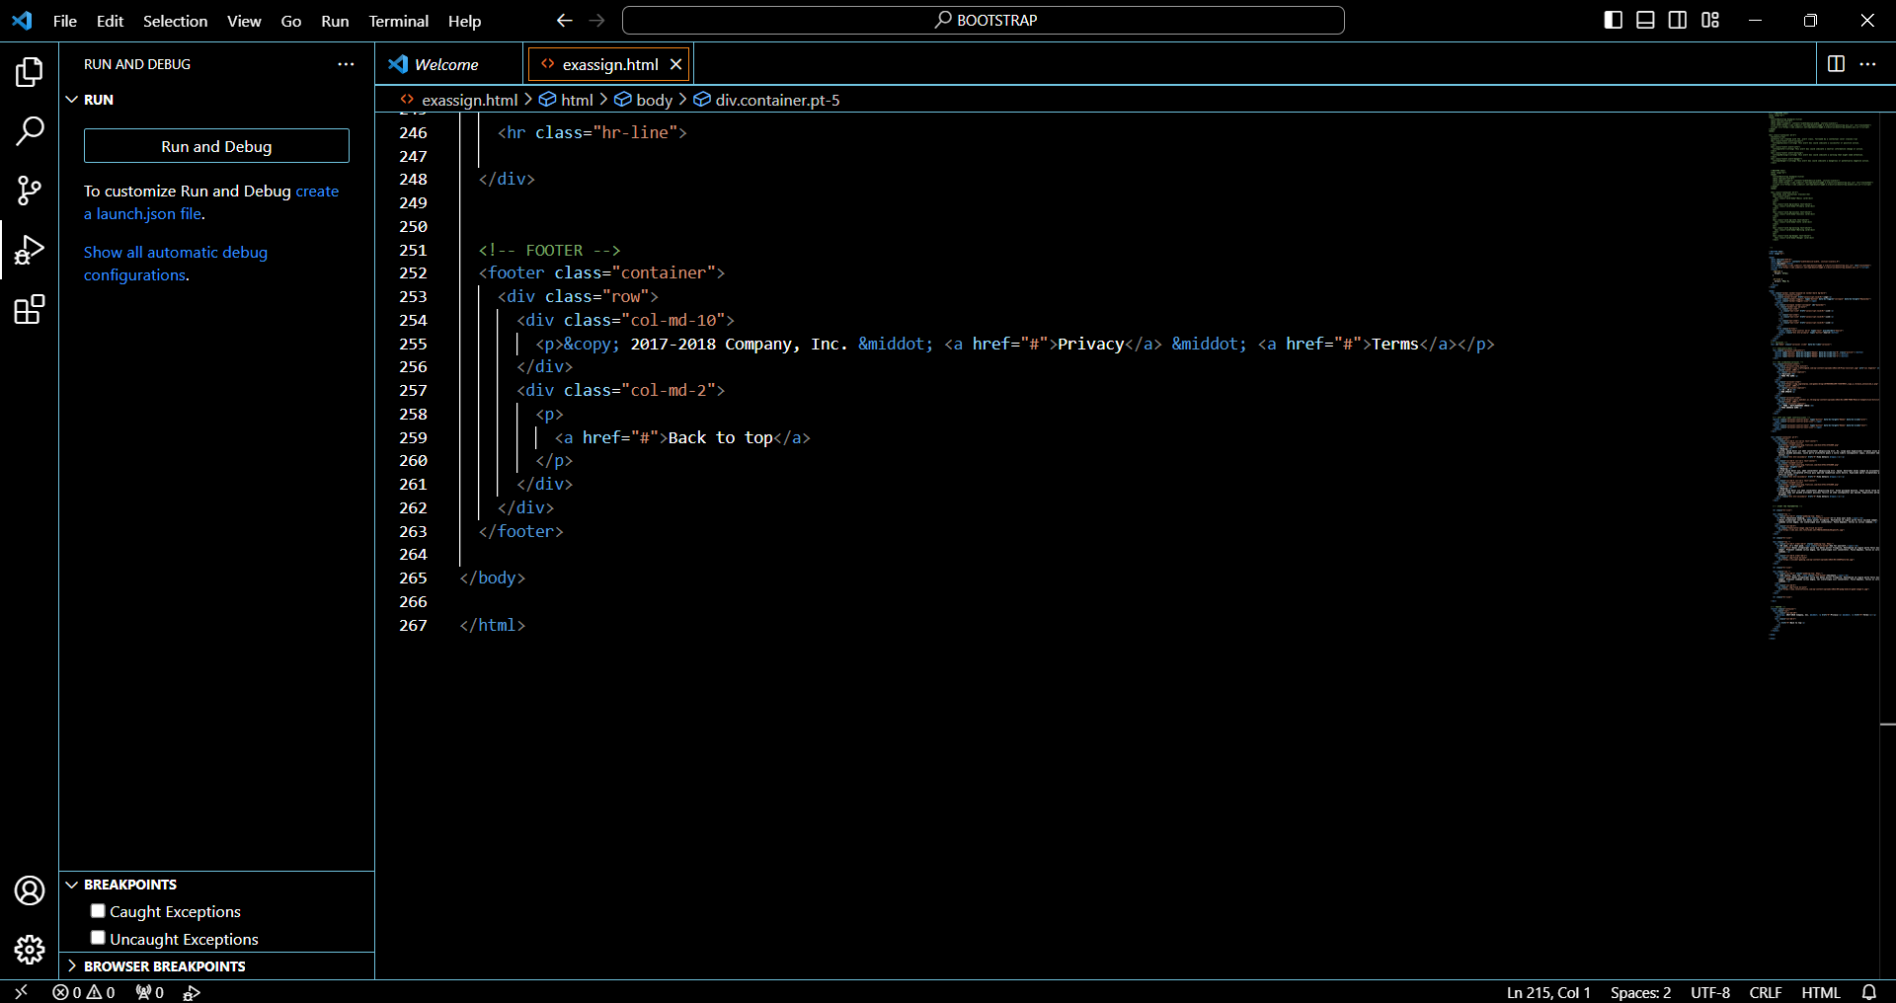

**OUTPUT:**

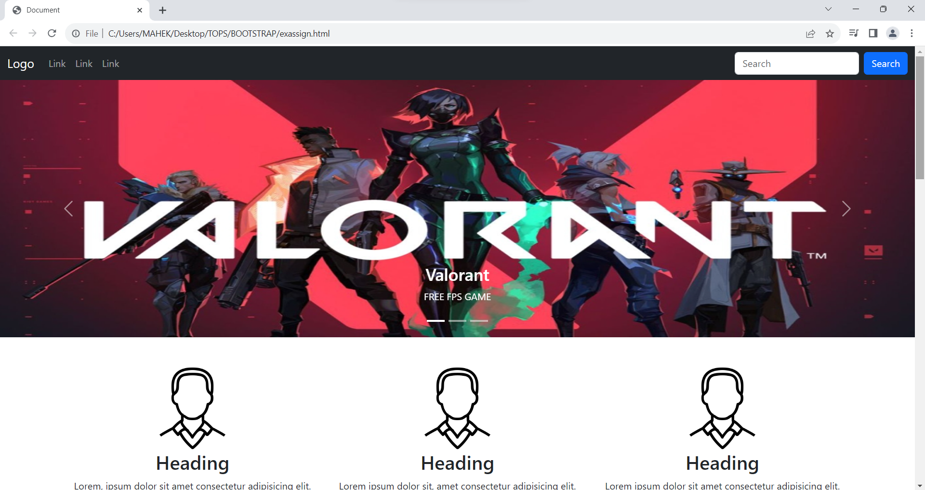

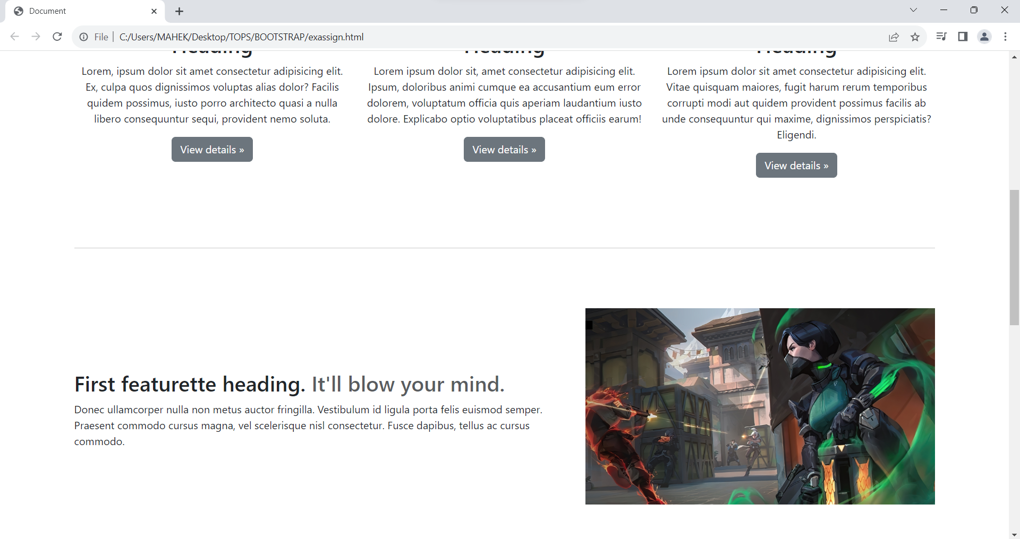

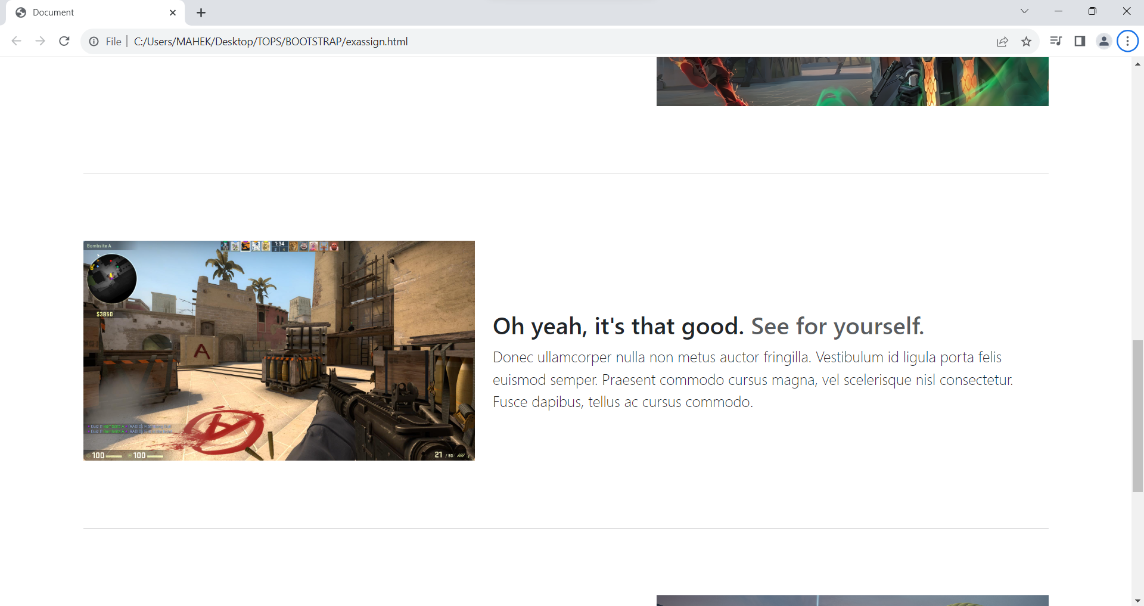

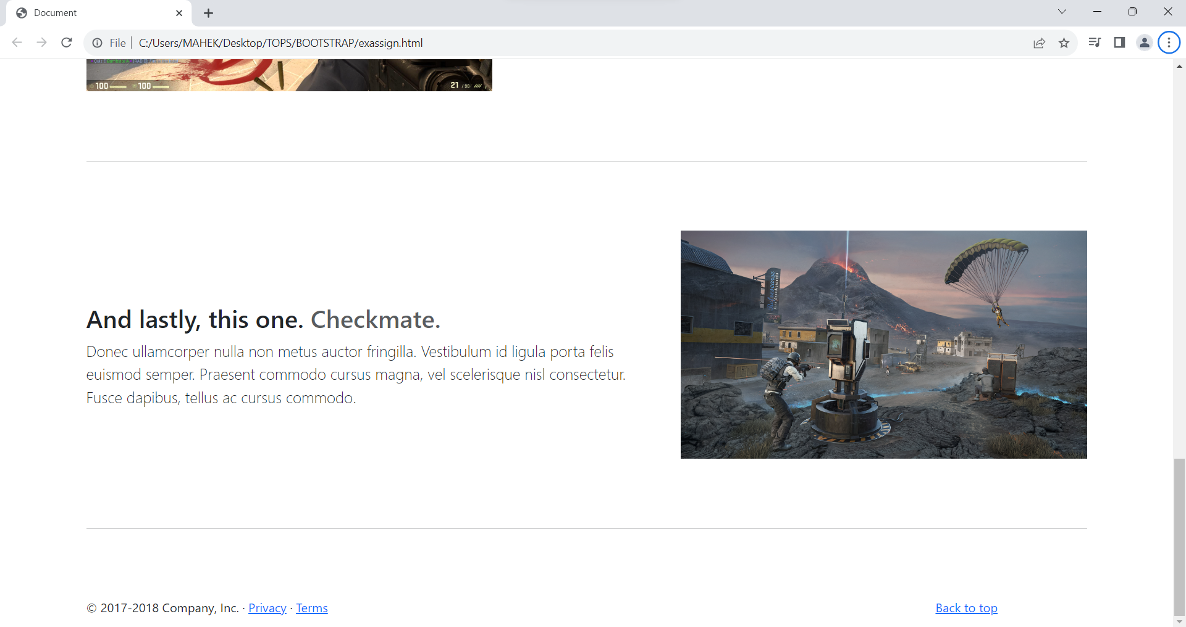

**<-----THE END----->**